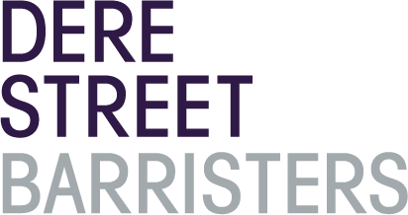
0
0
0

We may charge either fixed fees (which means that we will charge you a set amount of money for each piece of work we undertake) or on an hourly rate basis. Below we provide estimates based on the ranges of fixed fees and the hourly rates for barristers at Dere Street.

All fees exclude VAT (where applicable). That means that it is likely that you will have to pay us VAT in addition to the fee at the current rate (presently 20%).

If we charge fixed fees, these may vary depending on your needs – for example, your fees may be towards the higher end of the range if you need a more experienced barrister and/or you have a more complex case. If you have a particularly complex case, your fees may also be higher than the estimates below. There may also be additional costs for any administrative work involved such as copying or where you agree to engage another person to assist with your case.

If we quote a fixed fee it will only be to undertake that particular piece of work. There are likely to be many different pieces of work involved in a case such as representation at hearings, advising in conference and in writing and drafting documents. We will always quote separately for each piece of work. Below are some indicative fees;

Stage of Case | Range of fixed fees (estimated)
Preliminary meeting | £0 - £500
Initial conference | £500 - £2000
Written advice on claim | £500 - £2000
Hourly rate for assistance with drafting any Court documents | £200 - £500
Preliminary / Directions hearings | £750 - £2500
Preparation of case, drafting documents | £500 - £2000
1 day hearing – County Court / Tribunal | £1500 - £5000

Contact Us

All information is correct as of November 2020 but fees are estimates only and may change.

For a more accurate quotation please contact the clerks on 0344 335 1551 or clerks@derestreet.co.uk

