**PERSONAL SUMMARY**

Having previously worked for the Crown Prosecution Service Laurie brings her experience and training on the Code for Crown Prosecutors into her regulatory work, providing thorough and balanced advice on the merits of undertaking regulatory prosecutions.

Laurie was also previously employed by a large North East local authority, working closely with their health and safety team to investigate accidents at work, ensure compliance with reporting obligations, and prevent re-occurrence.

She therefore also brings to her regulatory work a unique understanding of her professional clients.



**Practice Areas**

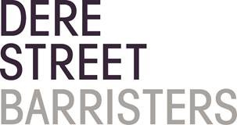 Regulatory Law

LAURIE SCOTT

Barrister

**Civil**

**Crime**

**Regulatory Law**

**AREAS OF EXPERTISE**

Laurie provides advice and representation to local authorities on matters such as:

• Trading standards

• Health and Safety Prosecutions

• Criminal Law

• Civil Law

**PERSONAL SKILLS**

Laurie is an accomplished advocate and appears on a daily basis before both the civil and criminal courts, in addition to advising on evidential and procedural issues, and drafting legal documents in connection with her cases. She is known for her friendly and approachable manner with professional and lay clients alike. Laurie has a balanced practice of prosecution and defence criminal work, and equally acts for Claimants and Defendants in the civil courts. Laurie is also accredited by the Bar Council to accept instructions on a direct access basis.

 l.scott@derestreet.co.uk

 l.scott@derestreet.co.uk.cjsm.net

Year of Call 2003