**PERSONAL SUMMARY**

Former deputy coroner, with eleven years experience of medical regulation as Legal Assessor to the General Medical Council and Legal Advisor to the general Dental Council. David has experience in appearing as an advocate in inquests.

He has practised in many areas of law but he now concentrates on employment and discrimination cases. His work includes work for two police forces in the south of England. He has been extensively instructed by local authorities and other large organisations and businesses.

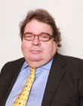

**Civil**

**Regulatory Law**

**Practice Areas**

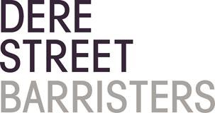 Regulatory Law

DAVID MASON

Barrister, Mediator, Journalist and Author

 d.mason@derestreet.co.uk

 d.mason@derestreet.co.uk.cjsm.net

**AREAS OF EXPERTISE**

* Inquest
* Police Disciplinary

**PROFFESIONAL EXPERIENCE**

Solicitor for about twelve years before call to the Bar. With decades of experience as an advocate he is effective in any proceedings. He has appeared in many types of case, including jury trials and appearances in the Court of Appeal and the Chancery Division.

**EDUCATION AND PROFESSIONAL QUALIFICATIONS**

1970 – Graduated Nottingham University

Employment Tribunal chairman for nine years

Former Head of Equity chambers, a specialist employment law set

Presently Chambers’ Equal Opportunities Officer

Year of Call 1984

**What others have to say**

**‘**David’s tactical awareness is second to none and includes his knowledge of pre-dismissal advice, litigation support as well as his exceptional tribunal advocacy skills. He is a proven heavy weight, who carefully, subtly and deftly addresses a case from start to finish. I would without hesitation recommend David and am conscious that every one of my clients David represented has expressed their admiration at his ability.’

**Damian Robson, Associate, Ward Hadaway**