**PERSONAL SUMMARY**

Jonathan advises and represents local authorities, individuals, partnerships and limited companies on consumer protection and trading standard matters including undertakings under the Enterprise Act 2002.



**Practice Areas**

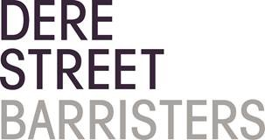 Regulatory Law

JONATHAN CARR

Barrister

**AREAS OF EXPERTISE**

Jonathan has a background specialising in clinical and dental negligence cases. He advises and represents the dental profession in proceedings before the General Dental Council, particularly in relation to hearings before the Interim Orders Committee and the Professional Conduct Committee.

**PERSONAL SKILLS**

Jonathan prides himself on building good relationships with both instructing solicitors and lay clients. Jonathan is always thoroughly prepared for all cases and this is evident in his presentation of the case at court. Client’s, both professional and lay, find Jonathan professional, approachable and very easy to work with.

**EDUCATION AND PROFESSIONAL QUALIFICATIONS**

Durham School

Newcastle University LLB (Hons)

 j.carr@derestreet.co.uk

 j.carr@derestreet.co.uk.cjsm.net

**Civil**

**Regulatory Law**

Year of Call 1990