**PERSONAL SUMMARY**

David Robinson-Young brings a broad depth of experience from outside the Bar making him a highly effective advocate with a focused ability to listen and communicate. He is highly motivated, driven with a dogged determination to put forward his client’s case. Clients find him approachable, dependable and thorough.

David has been certified by the Bar Council to accept instructions under the Direct Access to the Bar scheme and will happily offer advice in this respect if the circumstances of the case allow.



**Practice Areas**

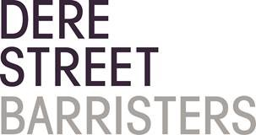 Regulatory Law

DAVID ROBINSON-YOUNG

Barrister

 d.robinsonyoung@derestreet.co.uk

 d.robinsonyoung@derestreet.co.uk.cjsm.net

**AREAS OF EXPERTISE**

• Police Disciplinary

• Healthcare Regulators

Formerly practicing in criminal law David has specialised in discrimination and employment law since 2007. Regulatory work was an organic evolution of his practice.

**PERSONAL SKILLS**

A gifted communicator, skilled at interviewing witnesses for the purpose of uncovering relevant evidential points.

Robust and reactive in cross examination.

Quick to assimilate the facts of a case and apply the relevant law.

**PROFFESIONAL EXPERIENCE**

David trained as a pupil in the Temple, London and was involved in the Marchioness Inquiry, the Derbyshire Inquiry and the Gaul Inquiry. Since returning to his native north east he has worked in Crime, Employment and Regulatory work.

**Employment**

**Regulatory Law**

Year of Call 1999